APPENDICES

Appendix 3: Template Characteristic Spirit of a Community School under the joint patronage of Catholic and ETB patrons

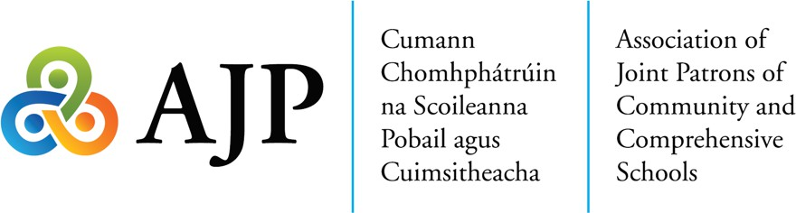

Template Characteristic Spirit of a Community School under the joint patronage of Catholic and ETB patrons:
XX School Community school is a co-educational/all girls/all boys multi-denominational post-primary school under the joint patronage of XX Bishop and/or Religious Congregation and XX ETB.
Community Schools provide a comprehensive system of post-primary education open to all the children of the local community. An innovative approach to delivery of a wide- ranging curriculum contributes to the spiritual, moral, mental, physical and social well- being of students within their community. Community Schools may also provide for
life-long learning within their local community through the provision of adult education programmes.
Our school was established under the Deed of Trust and opened on XX date. (Schools should customise to make reference to how the school was established e.g. amalgamation, greenfield site). The values of XX ETB as a multi-denominational State Body and the inherited traditions, Christian values and founding intentions of XX Bishop and/or Religious Congregation are enshrined in the characteristic spirit and in the life of our school and are respected and cherished.

The core values of XX Community School are care, respect, community, inclusion, equality, justice and fairness. These values combine to provide and support an atmosphere which is conducive to excellence in teaching and learning. We endeavour to assist each student to reach his/her full potential in a calm, caring and creative environment.

38

APPENDICES

Our values are reflected in how we live as a school community. The unique and intrinsic value of each member of the school community is recognised and respected. All are treated equally, regardless of race, gender, religion/belief, age, family status, marital status, civil status, membership of the Traveller community, sexual orientation, ability, disability or socio-economic status. All students are given equal opportunity for enrolment, in line with the Education (Admissions to School) Act (2018) construed in accordance with section 3 of the Equal Status Act 2000. Once enrolled, our school (school XX) provide all our students with equal opportunities to engage with the curriculum, school life and the local community.
Our school (school XX) provides a safe physical and social environment that reinforces a sense of belonging to the school community and wider society. We strive to enable every student to realise their full potential regardless of any aspect of their identity, culture or background. Our school promotes a fully inclusive education which recognises the plurality of identities, beliefs and values held by students, parents and staff. ;\Te prepare open-minded and responsible citizens with a strong sense of shared values with a view to contributing to a just and fairer society.
Our school is multi-denominational where we welcome, respect and support students of all religions and beliefs. The provision of religious education, religious worship and the work of the Chaplain all combine to reflect the founding intention of the school, the school's mission statement and the needs of the students within the school. The characteristic spirit of the school finds practical expression through the provision of pastoral, liturgical and social outreach activities, as appropriate, for each student.
In (School XX), we celebrate the partnership, collaboration and empathy which nurtures and develops our young people in a community where the essence of our ethos is care and respect for self, others, and our environment.

39

