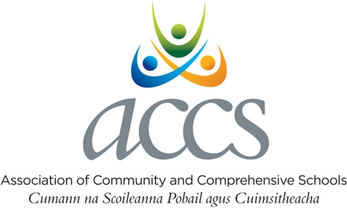

Template: End of School Year Report to Joint Trustees/Patrons

School Name: XXXX Community School/Comprehensive School
Joint Trustees:

1.

2.

3.

Chairperson of Board of Management:

Liasion Trustee:

Signed: Date:
(Chair)

Signed: Date:
(Principal)

Table of Contents

Contact Details

Characteristic Spirit Statement School Mission Statement Brief History of School
School Location, Catchment Area
Map if relevant included at Appendix 1

Board of Management (Term: 20XX – 20YY ) School Personnel
School Policies

Parents’ Association/Council Report Student Council Report
Student Profile School Enrolments
School Self-Evaluation Reports Curriculum and Extracurricular Activities School Accommodation/Facilities
School Finance
Opportunities and Challenges
3

4

4

5

5

6

6

7

8

8

9

9

10

10-11

12

13

13

Contact Details

School Roll Number:

School Address:

School Telephone Number:

School Email:

School Web Address:

Is the school registered as a Charity with the Charity Regulatory Authority? If so, School Charity No:

Principal’s contact details

Name:

Telephone number: Mobile number: E-mail (print please):

Deputy Principal(s)

Name: Name: Name: Chaplain Name:

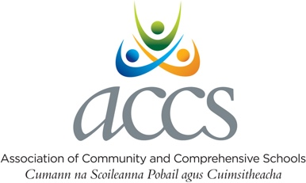

Characteristic Spirit Statement:

School Mission Statement:

Brief History of School:

School Location, Catchment Area:
Map if relevant included in Appendix 1

E.G. XXX is a small town in County XXX, Ireland. It lies at the crossroads where the R and R regional roads meet. XXX is the closest town to XXX in the north-eastern corner of County XXX.
XXX Community School serves the communities of xxxx and xxxx and xxxx.

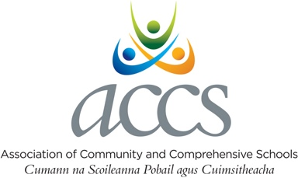
Leadership & Management

Board of Management
(Term: 20XX - 20YY)
Trustee Nominees: Trustee Nominees: Teacher Nominees: Parent Nominees: Chairperson: Secretary to the BOM:

School Personnel
Teaching & Non-Teaching Staff
Total Number of Teachers on Staff:
Number of Permanent Whole-time Teachers:
(including CIDs): Allocation (WTE)

Number SNAs:
Number Clerical Officers/Secretaries: Number of Caretakers:
Number of Cleaners/Contract Cleaners: Other, e.g. Canteen etc. (SSSF):

PORs | AP1: | AP2:
Number:
Programme Coordinator:
Adult Education Programme:

School Policies

Policy | Has the policy been approved by the BOM? |  | Date of next review
Child Protection Procedures and Child Safeguarding Statement | Yes | No
Admission Policy * | Yes | No
Anti-Bullying Policy | Yes | No
Special educational needs/ Inclusion policy | Yes | No
School Code of Discipline/Behaviour | Yes | No
Critical Incident Management policy** | Yes | No
Data protection | Yes | No
The School Plan:  The annual SSE report and School Improvement Plan (SIP) | Yes | No
* Any amendments to the Admissions Policy must be sent to the patrons/trustees for approval.
** Patrons must be informed of a Critical Incident.

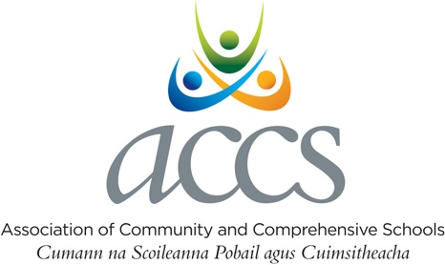

Parents’ Association/Council Report:

Name of Chairperson:
Name of Secretary:
Number of committee members:
Total number of members:
How many meetings were held in 20XX – 20YY:
Has the Parents Association been invited to meet the BOM? Yes No Brief report of activities 20XX – 20YY:

Student Council Report:
Name of Chairperson:  How many meetings were held in 20XX – 20YY:  Has the Student Council been invited to meet the BOM? | Yes | No
Brief report of activities 20XX – 20YY:

Student Profile

Is the School in the DEIS programme? yes no

Year Group | Total
1st Year
2nd Year
3rd Year
Transition Year
5th Year – Leaving Certificate
5th Year – Leaving Certificate Applied
6th Year – Leaving Certificate
6th Year – Leaving Certificate Applied
Post Leaving Certificate
Total
Adult Education (Hours)
Examination Profile
Number of students completed JC
Number of students completed LC

Student Enrolment Figures

 | Year | Enrolment
Previous 3 years | 2020/2021
 | 2021/2022
 | 2022/2023
Projected Enrolment | 2023/2024
 | 2024/2025
 | 2025/2026

School Self-Evaluation Reports
Has the school had a WSE-MLL? | yes | no
Is there Religious Education/Ethics provision of two hours each week? | yes | no
Curriculum Subjects offered at Senior Cycle

Subject | Subject | Subject
English
Irish
Maths

Curriculum Subjects offered at Junior Cycle

Subject | Subject | Subject
English
Irish
Maths

Short Courses offered at Junior Cycle

Level 2 Learning Programmes (L2LP)

Level 1 Learning Programmes (L1LP)

Current PLC courses offered and delivered

Subject/Course Title | Certification
Extra-Curricular Activities offered

School Accommodation/Facilities

% of Accommodation permanent
% of Accommodation prefabricated
Average age of prefabricated buildings
No of general classrooms
No of Science laboratories
No of Home Economics rooms
No of Art rooms
No of Metal Work rooms
No of Engineering rooms
No of Woodwork rooms
No of Building Construction rooms
No of Technical Graphics rooms
No of Design & Communications Graphics rooms
Music Room
Computer Labs
Demo Room
School Gym
School Sports Hall
Special Class /SNU

Has the Board applied for any building projects/grants? Has Trustee/Patron approval been sought?
yes no

yes no

Emergency / Additional Accommodation / Summer Works (circle relevant category)
Nature of work and date of completion:

School Finance
Have the school accounts been certified by an Independent accountant? | yes | no
Have the school accounts been forwarded to the FSSU? | yes | no
Have the school accounts been forwarded to the patrons? | yes | no
Is there a Board Finance Sub Committee in place? | yes | no

What are the opportunities and challenges facing the school over the next 3-5 years?

Opportunities | Challenges
1. | 1.
2. | 2.
3. | 3.

Any additional Information regarding Board plans/ for the school/ current strategic plan etc.

