APPENDICES

Appendix 5: DE Letter re change of policy on selection committees
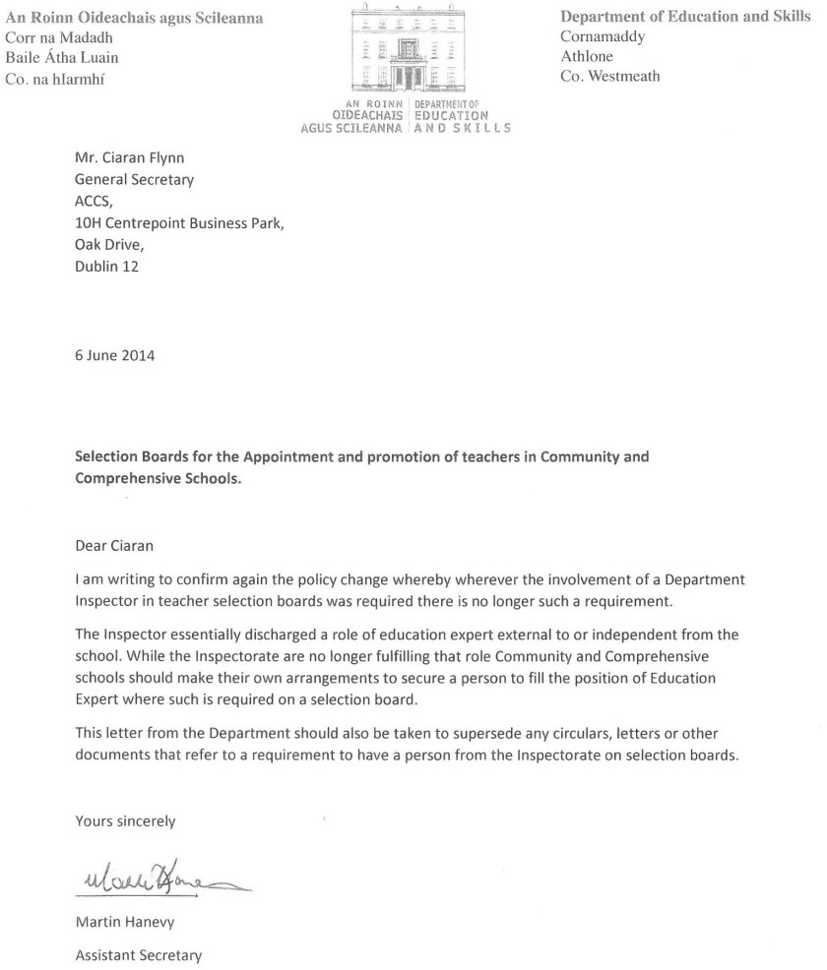

43

