 | https://www.microsoft.com/en-ie
 | https://www.pcigroup.ie
 | https://www.athena.ie
 | https://www.compass.education/
 | https://www.cornmarket.ie
 | https://www.databizsolutions.ie
 | https://www.drinkaware.ie
 | https://www.dunneaccountants.com
 | https://www.easypaymentsplus.com
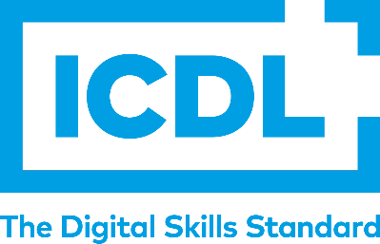 | https://www.icdl.ie/schools/
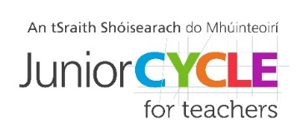 | https://www.jct.ie
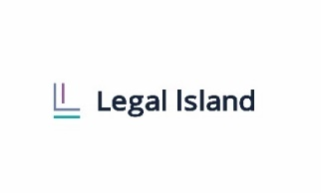 | https://www.legal-island.ie/
 | https://www.odoherty.biz
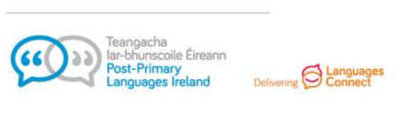 | https://www.ppli.ie
 | https://www.prodigylearning.com
 | https://www.protectoratesolutions.com
 | https://www.examcraftgroup.ie
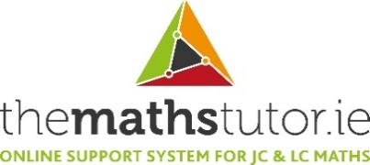 | https://www.themathstutor.ie
 | https://www.vsware.ie
 | https://www.wrigglelearning.ie

